
We are proud that Joy in Christ is a Stephen Ministry Congregation, serving our members and community.

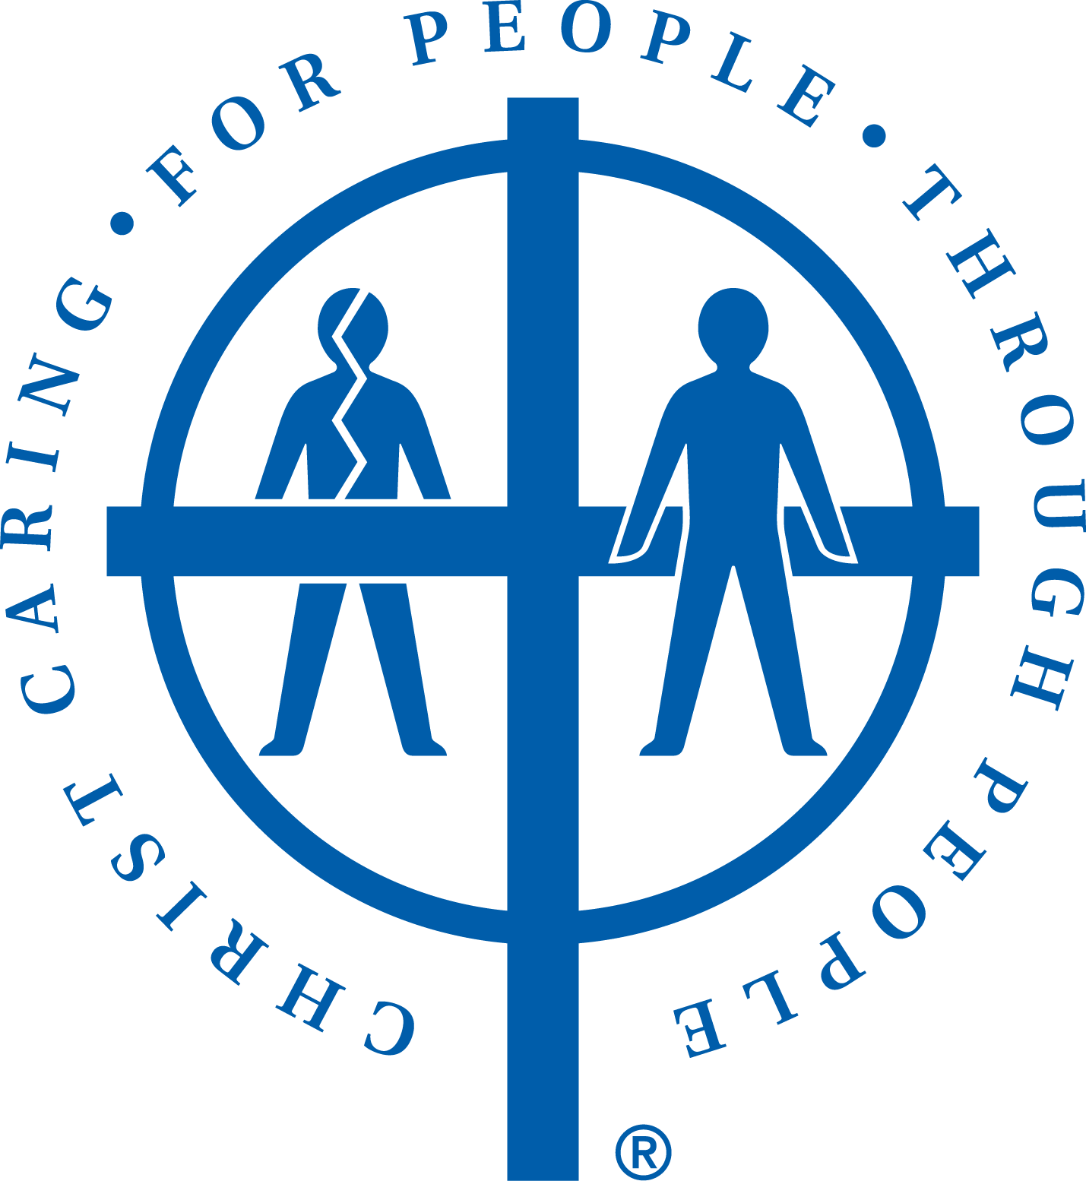
What exactly is a Stephen Minister?

Stephen Ministers are lay congregation members trained to provide one-on-one emotional and spiritual support to people going through difficult times in life, providing hope and healing in the midst of their pain.

None of us glides through life without ever hitting a rough patch. At times we may face grief, chronic or terminal illness, family discord, tough choices, and more – all accompanied by strong emotions or fear. What a blessing to find that special listener to walk alongside when you’re struggling just to put one foot in front of the other.

We have caring, trained lay people right here, ready and able through their caring presence to be God’s ears, God’s eyes and God’s heart – providing hope to people at a time when they need it most. Through an extensive training program, these caregivers have learned principles and skills that equip them to provide high-quality, Christ-centered emotional and spiritual care to others. A care receiver and a Stephen Minister are matched by gender, and typically agree to meet weekly for as long as the need for care exists. Know that strict confidentiality is a key component of Stephen Ministry.

Interested in learning more?
Contact Pastor Julie, at 501-915-9569, or
Stephen Leaders: Dorothy Fager 501-226-5215, Susan Maser 708-296-6692

*** Bear one another’s burdens, and in this way you will fulfill the law of Christ. - Galations 6:2 ***

